DDEF Analyzer Tool Guide
Zasha Griffin
Contents
Introduction 1
About 1
Contact 1
Using The Tool 2
Required Documents 2
Tool Component Explanation **Key** 2
Output Guide 3
Step-By-Step Instructions 3
Troubleshooting 5
Error Guide 7

Introduction

About
The associated Excel sheet, DDEF Analyzer.xlsx, utilizes Python in Excel to clarify and speed up the processing of DDEFs. The tool aims to easily separate and categorize any issues present in a provided DDEF by comparing it against a disposition obligation and/or an older DDEF version.
Python is a widely used programming language that can easily handle complex or large-size data management. While it requires typical programming, it can effectively and cleanly handle data.
NOTE: Generative AI, like Google’s Gemini, can generate, adjust, and create Python code very easily.

Contact
For any issues or questions, please contact the author of this tool, Zasha Griffin, by phone or email. When emailing, please specify that you are having an issue with this tool. If you are not sure what the error is, it may be required to have a video conference. Before contact, ensure that the troubleshooting process has been complete.
Email: Griffinz24@students.ecu.edu
Call/Text: (828) 318-6343

Using The Tool

Required Documents
To use this tool, you will need to gather the following documents/Excel files…
- A recent DDEF report (standard format).
- An older DDEF report (standard format).
- A recent DDEF (sequence number format).
- A recent disposition obligation form.

Tool Component Explanation **Key**
This section is a critical component of this user guide and highlights the components and section of the tool.
This workbook has 7 sheets, “NewDDEF”, “OldDDEF”, “SeqNbr”, “Disposition_Obligation”, “Comparison”, “Ready for FM”, and “Mismatch Data”.
Figure 1: Sheet names

Each of these sheet functions as a core component of the tool.
The first four sheets (marked orange below) are considered “input sheets”. You will be adding data to them to give the last 3 (marked green below) “output sheets” functionality.
Figure 2: Input/Output sheets

The first sheet, “NewDDEF”, will be a direct copy and paste from a recent DDEF.
The second sheet, “OldDDEF”, will be a direct copy and paste from an older DDEF.
The third sheet, “SeqNbr”, comes from copy and pasting the “PIIN” column and “SEQNBR” column from a recent DDEF (in SeqNbr form).
The fourth sheet, “Disposition_Obligation”, is a direct copy and paste from a recent Disposition Obligation.
The fifth sheet, Comparison, has two components. It is where you can track the date of the new and old DDEF. It is where you view the new PIINs and the finished PIINs.
The sixth sheet, “Ready for FM”, is the full list of PIINs and their associated data that had a lower amount paid in the DDEF than in the Disposition Obligation. This list also includes PIINs with a cost that is matching in Disposition Obligation and DDEF. They also exclude any bad subhead-fund code matches. These should be ready to package and send to FM.
The seventh sheet, “Mismatch Data”, is the catch all for any PIINs that have a higher cost in the DDEF than the Disposition Obligation or that have an incompatible fund code.

Output Guide
This section will provide you with guidance on where to find information when using this tool.
What | Where
What PIINs are ready for FM? | These can be found in the “Ready for FM” sheet. These PIINs contain the full set of information required for FM. These PIINs had a lower amount paid in the DDEF than the total cost in the Disposition Obligation.
How do I find the PIINs I need to work? | These can be found in the “Mismatch Data” sheet. This will include PIINs that have an amount paid that is higher in the DDEF than the total cost in the Disposition Obligation. This section will also show any PIINs that have a mismatch between the subhead and the fund code on the DDEF.

Step-By-Step Instructions
This section will highlight the step-by-step instructions on using this tool. To get started in this section, ensure you have the required Excel file, DDEF Analyzer.xlsx. If you do not currently have it, navigate to this site (https://github.com/Griffinz24/ddef) and download the file, “DDEF Analyzer.xlsx”. Now that you have the file, follow the below instructions in order. For questions, feel free to reach out to griffinz24@students.ecu.edu.
It is advised to read the “Tool Component Explanation” section before beginning.
- With your new semi-blanked Excel file, you should have the following sheets:
    - Inputs: “NewDDEF”, “OldDDEF”, “SeqNbr”, “Disposition_Obligation”
    - Outputs: “Comparison”, “Ready for FM”, “Mismatch Data”
  - If any of these sheets are not present from the start, email Griffinz24@students.ecu.edu
  - If you decide to import or add new sheets, you will need to match these sheet names exactly.
- Now, you must gather the following documents from EPR/ERP.
  - A recent DDEF report (standard format).
  - An older DDEF report (standard format).
  - A recent DDEF (sequence number format).
  - A recent disposition obligation form.
- Once you have downloaded the previous files, copy and paste the following…
  - From the recent DDEF (stnd), copy and paste columns A-BU onto “NewDDEF” [A-BU]. You should paste into the A1 cell.
  - From the older DDEF, copy and paste columns A-BU onto “OldDDEF” columns A-BU. You should paste into the A1 cell.
  - From a recent DDEF (sequence number) copy and paste columns “PIIN” and “SEQNBR” from the DDEF onto the “SeqNbr” sheet. The PIIN number should go in column A, the sequence number should go into column B.
  - From the Disposition Obligation, copy and paste the entire document into the “Disposition_Obligation” sheet.
- Now that the new DDEF has been uploaded, do the following steps to prepare the sequence number. This only needs to be done in the “NewDDEF” sheet.
  - Click on the cell BV2 (far right cell).
  - Check to see if a formula is already added. If it is, do not modify.
  - If the cell is empty, add the formula…
    - =VLOOKUP(AH2,SeqNbr!A:B,2,FALSE)
      - The number after “AH” must match the row number.
Ex. Row 5 = =VLOOKUP(AH5,SeqNbr!A:B,2,FALSE).
  - Then drag down the formula using the bottom right corner.
- Next, navigate to the DDEF’s (this process will be done on both the new and old DDEF).
  - Drag to select all the cells in column AD, “Amt Paid”.
  - Click the warning sign.
  - Click “Convert to numbers”.
  - Repeat for both DDEFs.
    - Ensure you do not add a column
    - Ensure that you keep the values exactly the same, the tool will automatically divide by 100.
- Now that data has been added and uploaded, navigate to the “Comparison” sheet and input the dates from your DDEF’s in cell C2 and E2.
- You have now successfully prepared the tool for use.
- In an ideal scenario, all your fields in your output sheets (highlighted light blue) should populate.
  - You may see the error #NUM! – While this error looks intimidating, it is Python in Excel’s way of saying “this cell is blank”. You should expect to see this frequently on the “Comparison “sheet and the “Mismatch Data” sheet.
    - Similarly, the #BUSY! error is Excel’s way of saying that it is thinking.
  - If you get any other errors (#REF!, #CONNECT!, #REF!), navigate to the Error Guide (bottom of the document). This will direct you on the steps necessary to fix any issues.
- You may see cells that say #BUSY! or have a green @ sign, this is not an error, Excel is thinking (see below).
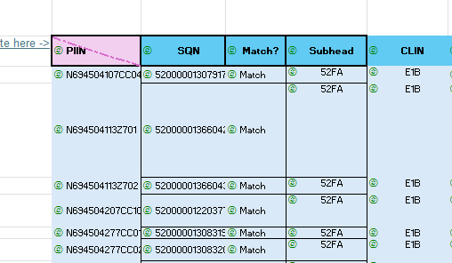
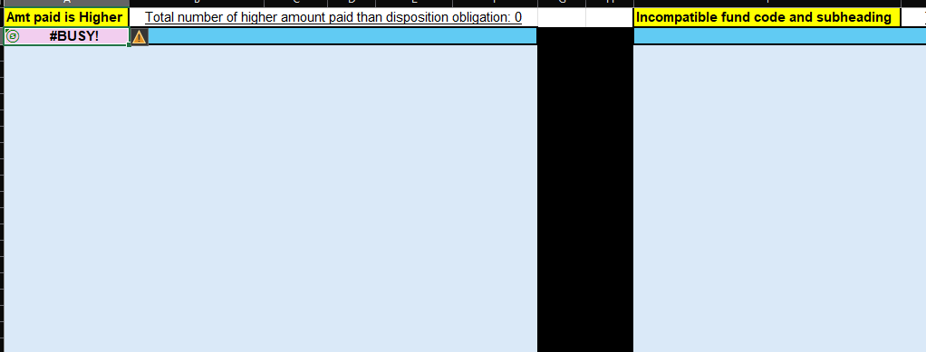
Figure 3: Example of #BUSY! error

End of step-by-step instructions.

Troubleshooting
This section should only be used after visiting the Error Guide. If your error is not fixed by either the Error Guide or this Troubleshooting section, email Griffinz24@students.ecu.edu. This is primarily how to replace any broken code.
- First, ensure all sheets are named EXACTLY as shown in step 1 of the main instructions.
  - If you have added/imported sheets, ensure they match as well.
- Ensure that you have added the SeqNbr formula to the far right column of the “NewDDEF” sheet.
- Ensure that the DDEF “Amt Paid” column has been converted to numbers. This is step 4 of the main instructions
- If none of these problems solve the problem, navigate to this GitHub page - https://github.com/Griffinz24/ddef
  - Find your broken/missing section. The name convention should be easy to interpret.
  - Click the link for the broken section.
  - Click the “copy raw data” button (see red box below).
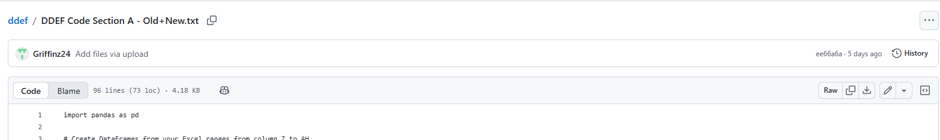
Figure 4: Copy raw data button highlight

  - Navigate to your excel file. Click on the pink-highlighted cell that has your error code. Open the formula box by clicking into it (see red X below).
    - When you open the formula box make sure you see the green stripe that says “PY” (boxed in orange below).
      - If you do not see this refer to the sub step on part ii.
    - Use the keyboard shortcut CTRL+A.
      - If you didn’t see the “PY” stripe, before pasting, type (without quotation marks) “PY(“ . You should now see the green stripe appear.
    - Use the paste shortcut CTRL+V.
    - Once you have pasted the full data, click the green checkmark (circled in purple below).
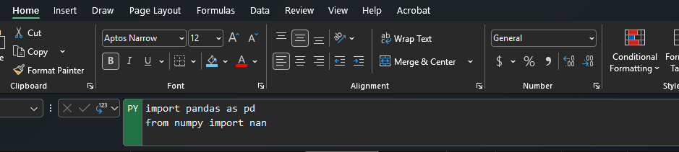
Figure 5: Formula box guide

  - If this did not solve your problem, please contact Zasha Griffin at griffinz24@students.ecu.edu.

Error Guide
This error guide is used to identify any potential error codes and offer solutions to fix the problem.
Error Code: #REF!
Explanation: One of your sheet names is messed up or a sheet name reference has been broken!
Fix: Follow the troubleshooting guide for how to replace the code.

Error Code: #NUM!
Explanation: This is not an error! This is just a way for Python in Excel to show a cell as blank.
Fix: N/A

Error Code: #BUSY!
Explanation: This is not an error! This is just a way for Python in Excel to show that it is thinking/computing. This will usually take a handful of minutes/seconds.
Fix: N/A

Error Code: #CONNECT!
Explanation: This means that your connection has timed out. It will stop every computation.
Fix: Save the document and reopen it.

Error Code: #BLOCKED!
Explanation: This means you have lost internet connection or are not fully connected to a safe/supported wifi network.
Fix: See if your connection issues can be fixed, if not, try again later.

Error Code: #CALC!
Explanation: This can mean a wide variety of things.
Fix: The best steps are to follow the Troubleshooting section. Otherwise, you may need to contact griffinz24@students.ecu.edu.

Error Code: #SPILL!
Explanation: This error means that the excel code is trying to display data in a range but a occupied cell is “blocking” it. Essentially, there is a cell that is occupied in any light-blue highlighted area.
Fix: Delete the non-code occupied cells in the light blue area.

This is the end of this document. Enjoy the tool.

